Chapter 1:
Industrial Control

1.1 Industrial Control
In recent years the performance requirements for process plants have become increasingly difficult to satisfy. Stronger competition, tougher environmental and safety regulations, and rapidly changing economic conditions have been key factors in tightening product quality specifications. A further complication is that modern plants have become more difficult to operate because of the trend toward complex and highly integrated processes. For such plants, it is difficult to prevent disturbances from propagating from one unit to other interconnected units.
In view of the increased emphasis placed on safe, efficient plant operation, it is only natural that the subject of process control has become increasingly important in recent years. Without computer-based process control systems it would be impossible to operate modern plants safely and profitably while satisfying product quality and environmental requirements.
The primary objective of process control is to maintain a process at the desired operating conditions, safely and efficiently, while satisfying environmental and product quality requirements. The subject of process control is concerned with how to achieve these goals. In large-scale, integrated processing plants such as oil refineries or ethylene plants, thousands of process variables such as compositions, temperatures, and pressures are measured and must be controlled. Fortunately, large numbers of process variables (mainly flow rates) can usually be manipulated for this purpose. Feedback control systems compare measurements with their desired values and then adjust the manipulated variables accordingly.
The specific objectives of control are:
  - Increased product throughput
  - Increased yield of higher valued products
  - Decreased energy consumption
  - Decreased pollution
  - Decreased off-spec product
  - Increased Safety
  - Extended life of equipment
  - Improved Operability
  - Decreased production labor

Industrial control system (ICS) is a general term that encompasses several types of control systems, including Supervisory Control And Data Acquisition (SCADA) systems, Distributed Control Systems (DCS), and other smaller control system configurations such as skid-mounted Programmable Logic Controllers (PLC) often found in the industrial sectors and critical infrastructures. ICSs are typically used in industries such as electrical, water, oil and gas. Based on information received from remote stations, automated or operator-driven supervisory commands can be pushed to remote station control devices, which are often referred to as field devices. Field devices control local operations such as opening and closing valves and breakers, collecting data from sensor systems, and monitoring the local environment for alarm conditions.

PLC
On many industrial sites electronic relays and simple on-off controllers are used to sequence regulator movements; e.g. valves opening and closing. Such controllers are known as logic controllers or sequence controllers.
These systems are gradually being replaced by sequence controllers based on as programmable logic controllers (PLCs). They have a modular design so they can be expanded to cover more areas of the process operation as it becomes automated. They can also incorporate advanced types of controllers.
A Programmable Logic Controller, PLC, or Programmable Controller is a digital computer used for automation of industrial processes, such as control of machinery on factory assembly lines. Unlike general-purpose computers, the PLC is designed for multiple inputs and output arrangements, extended temperature ranges, immunity to electrical noise, and resistance to vibration and impact. Programs to control machine operation are typically stored in battery-backed or non-volatile memory. A PLC is an example of a real-time system since output results must be produced in response to input conditions within a bounded time, otherwise unintended operation will result.
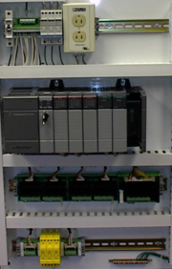
Figure 1.1 Control panel with PLC.
The main difference from other computers is that PLC are armored for severe condition (dust, moisture, heat, cold, etc) and have the facility for extensive input/output (I/O) arrangements. These connect the PLC to sensors and actuators. PLCs read limit switches, analog process variables (such as temperature and pressure), and the positions of complex positioning systems. Some even use machine vision. On the actuator side, PLCs operate electric motors, pneumatic or hydraulic cylinders, magnetic relays or solenoids, or analog outputs. The input/output arrangements may be built into a simple PLC, or the PLC may have external I/O modules attached to a computer network that plugs into the PLC.
PLCs were invented as replacements for automated systems that would use hundreds or thousands of relays, cam timers, and drum sequencers. Often, a single PLC can be programmed to replace thousands of relays. Programmable controllers were initially adopted by the automotive manufacturing industry, where software revision replaced the re-wiring of hard-wired control panels when production models changed.
Many of the earliest PLCs expressed all decision making logic in simple ladder logic which appeared similar to electrical schematic diagrams. The electricians were quite able to trace out circuit problems with schematic diagrams using ladder logic. This program notation was chosen to reduce training demands for the existing technicians. Other early PLCs used a form of instruction list programming, based on a stack-based logic solver.
The functionality of the PLC has evolved over the years to include sequential relay control, motion control, process control, distributed control systems and networking. The data handling, storage, processing power and communication capabilities of some modern PLCs are approximately equivalent to desktop computers. PLC-like programming combined with remote I/O hardware, allow a general-purpose desktop computer to overlap some PLCs in certain applications.
Under the IEC 61131-3 standard, PLCs can be programmed using standards-based programming languages. A graphical programming notation called Sequential Function Charts is available on certain programmable controllers.
PLCs are well-adapted to a certain range of automation tasks. These are typically industrial processes in manufacturing where the cost of developing and maintaining the automation system is high relative to the total cost of the automation, and where changes to the system would be expected during its operational life. PLCs contain input and output devices compatible with industrial pilot devices and controls; little electrical design is required, and the design problem centers on expressing the desired sequence of operations in ladder logic (or function chart) notation. PLC applications are typically highly customized systems so the cost of a packaged PLC is low compared to the cost of a specific custom-built controller design. On the other hand, in the case of mass-produced goods, customized control systems are economic due to the lower cost of the components, which can be optimally chosen instead of a "generic" solution, and where the non-recurring engineering charges are spread over thousands of sales.

DCS
A distributed control system (DCS) refers to a control system usually of a manufacturing system, process or any kind of dynamic system, in which the controller elements are not central in location (like the brain) but are distributed throughout the system with each component sub-system controlled by one or more controllers. The entire system may be networked for communication and monitoring.
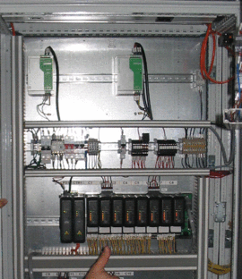
Figure 1.2 The part of DCS – DeltaV – Processor with I/O modules.
DCSs are normally used to control large or complex processes. They are modular systems that allow operators to adjust the set-points of many individual controllers from a central control. A central control unit monitors the operation of each of the other controllers and makes data available to other high-level systems, such as fault diagnosis, process optimization and production-scheduling systems.
A DCS typically uses computers (usually custom designed processors) as controllers and use both proprietary interconnections and protocols for communication. Input & output modules form component parts of the DCS. The processor receives information from input modules and sends information to output modules. The input modules receive information from input instruments in the process (aka field) and output modules transmit instructions to the output instruments in the field. Computer buses or electrical buses connect the processor and modules through multiplexers/demultiplexers. Buses also connect the distributed controllers with the central controller and finally to the Human-Machine Interface (HMI) or control consoles.
Distributed control systems (DCSs) are used in industrial, electrical, computer and instrumentation and control engineering applications to monitor and control distributed equipment with or without remote human intervention; the nomenclature for the former 'manual control' and the latter 'automated control'. DCS is a very broad term that describes solutions across a large variety of industries, including:
- Electrical power grids and electrical generation plants
- Environmental control systems
- Traffic signals
- Water management systems
- Refining and chemical plants
- Pharmaceutical manufacturing
- Sensor Networks
The broad architecture of a solution involves either a direct connection to physical equipment such as switches, pumps and valves or connection via a secondary system such as a SCADA system.
A DCS solution does not require operator intervention for its normal operation but with the line between SCADA and DCS merging, systems claiming to offer DCS may actually permit operator interaction via a SCADA system.
Distributed Control Systems (DCSs) are dedicated systems used to control manufacturing processes that are continuous or batch-oriented, such as oil refining, petrochemicals, central station power generation, pharmaceuticals, food & beverage manufacturing, cement production, steelmaking, and papermaking. DCSs are connected to sensors and actuators and use setpoint control to control the flow of material through the plant. The most common example is a setpoint control loop consisting of a pressure sensor, controller, and control valve. Pressure or flow measurements are transmitted to the controller, usually through the aid of a signal conditioning Input/Output (I/O) device. When the measured variable reaches a certain point, the controller instructs a valve or actuation device to open or close until the fluidic flow process reaches the desired setpoint. Large oil refineries have many thousands of I/O points and employ very large DCSs. Processes are not limited to fluidic flow through pipes, however, and can also include things like paper machines and their associated variable speed drives and motor control centers, cement kilns, mining operations, ore processing facilities, and many others.
A typical DCS consists of functionally and/or geographically distributed digital controllers capable of executing from 1 to 256 or more regulatory control loops in one control box. The input/output devices (I/O) can be integral with the controller or located remotely via a field network. Today’s controllers have extensive computational capabilities and, in addition to proportional, integral, and derivative (PID) control, can generally perform logic and sequential control.
DCSs may employ one or several workstations and can be configured at the workstation or by an off-line personal computer. Local communication is handled by a control network with transmission over twisted pair, coaxial, or fiber optic cable. A server and/or applications processor may be included in the system for extra computational, data collection, and reporting capability.

SCADA
The term SCADA is used differently in North America than in the rest of the world:
- In North America; SCADA refers to a large-scale, distributed measurement and control system.
- In the rest of the world; SCADA is any system that performs Supervisory Control And Data Acquisition, independent of its size or geographical distribution.
SCADA systems are typically used to perform data collection and control at the supervisory level. Some SCADA systems only monitor without doing control, these systems are still referred to as SCADA systems.
SCADA systems can be used to control a wide range of industrial processes and are often used to provide an operator interface for PLC-based control systems. They are software packages designed to run on a computer, with facilities for storing data for analysis. Advanced SCADA systems also incorporate advanced control algorithms that can help operators to automatically optimize process operations. Some advanced SCADA systems also include fault diagnosis and production scheduling systems.
The supervisory control system is a system that is placed on top of a real-time control system to control a process that is external to the SCADA system (i.e. a computer, by itself, is not a SCADA system even though it controls its own power consumption and cooling). This implies that the system is not critical to control the process in real-time, as there is a separate or integrated real-time automated control system that can respond quickly enough to compensate for process changes within the time-constants of the process. The process can be industrial, infrastructure or facility based as described below:
Industrial processes include: manufacturing/production/power generation/fabrication/refining - continuous, batch, repetitive or discrete.
Infrastructure processes may be public or private and include: water treatment and distribution, wastewater collection and wastewater treatment, oil & gas pipelines, electrical power transmission and distribution and large communication systems.
Facility processes in private or public facilities including: buildings, airports, ships or space stations in order to monitor and control: HVAC, access control, energy consumption management
The SCADA systems for these applications all perform Supervisory Control And Data Acquisition, even though the use of the systems are very different.
A SCADA system includes input/output signal hardware, controllers, HMI, networks, communication, database and software. It mainly comes in the branch of Instrumentation Engineering.
The term SCADA usually refers to a central system that monitors and controls a complete site or a system spread out over a long distance (kilometres/miles). The bulk of the site control is actually performed automatically by a Remote Terminal Unit (RTU) or by a Programmable Logic Controller (PLC). Host control functions are almost always restricted to basic site over-ride or supervisory level capability. For example, a PLC may control the flow of cooling water through part of an industrial process, but the SCADA system may allow an operator to change the control set point for the flow, and will allow any alarm conditions such as loss of flow or high temperature to be recorded and displayed. The feedback control loop is closed through the RTU or PLC; the SCADA system monitors the overall performance of that loop.
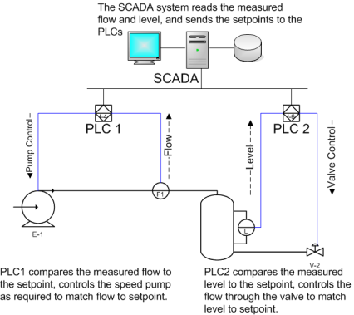
Figure 1.3 An example of a SCADA system.
Data acquisition begins at the RTU or PLC level and includes meter readings and equipment statuses that are communicated to SCADA as required. Data is then compiled and formatted in such a way that a control room operator using the HMI can make appropriate supervisory decisions that may be required to adjust or over-ride normal RTU (PLC) controls. Data may also be collected in to a Historian, often built on a commodity Database Management System, to allow trending and other analytical work.
SCADA systems typically implement a distributed database, commonly referred to as a tag database, which contains data elements called tags or points. A point represents a single input or output value monitored or controlled by the system. Points can be either "hard" or "soft". A hard point is representative of an actual input or output connected to the system, while a soft point represents the result of logic and math operations applied to other hard and soft points. Most implementations conceptually remove this distinction by making every property a "soft" point (expression) that can equal a single "hard" point in the simplest case. Point values are normally stored as value-timestamp combinations; the value and the timestamp when the value was recorded or calculated. A series of value-timestamp combinations is the history of that point. It's also common to store additional metadata with tags such as: path to field device and PLC register, design time comments, and even alarming information.
It is possible to purchase a SCADA system, or Distributed Control System (DCS) from a single supplier. It is more common to assemble a SCADA system from hardware and software components like Telvent, Allen-Bradley, ABB, Siemens, DirectLogic or GE PLCs, HMI packages from Adroit, Wonderware, Iconics, Rockwell Automation, Inductive Automation, Citect, or GE. Communication typically happens over ethernet.

Microcontrollers
A microcontroller (or MCU) is a computer-on-a-chip. It is a type of microprocessor emphasizing self-sufficiency and cost-effectiveness, in contrast to a general-purpose microprocessor (the kind used in a PC). The only difference between a microcontroller and a microprocessor is that a microprocessor has three parts - ALU, Control Unit and registers (like memory), but the microcontroller has additional elements like ROM, RAM etc.
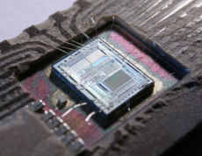
Figure 1.4 An example of a microcontroller: Intel 8742.
This is what is implemented in our project. Microcontrollers are used less frequently in industrial control since they are less robust. But they have the advantage of having fewer restrictions than PLC or SCADA: a skilled programmable may write any code (whether in C or assembly) to implement virtually anything he wants. In fact, a PLC may be implemented using a microcontroller. Therefore, special-cases or complex cases may be implemented using microcontrollers.

1.1.4 Comparisons
For high volume or very simple fixed automation tasks, different techniques are used. For example, a consumer dishwasher would be controlled by an electromechanical cam timer costing only a few dollars in production quantities.
A microcontroller-based design would be appropriate where hundreds or thousands of units will be produced and so the development cost (design of power supplies and input/output hardware) can be spread over many sales, and where the end-user would not need to alter the control. Automotive applications are an example; millions of units are built each year, and very few end-users alter the programming of these controllers. However, some specialty vehicles such as transit busses economically use PLCs instead of custom-designed controls, because the volumes are low and the development cost would be uneconomic.
Very complex process control, such as used in the chemical industry, may require algorithms and performance beyond the capability of even high-performance PLCs. Very high-speed or precision controls may also require customized solutions; for example, aircraft flight controls. In such cases, we need microcontrollers.
PLCs may include logic for single-variable feedback analog control loop, a "proportional, integral, derivative" or "PID controller." A PID loop could be used to control the temperature of a manufacturing process, for example. In fact, some PLCs have ready-made complex modules such as PID tuning and fuzzy control. Historically PLCs were usually configured with only a few analog control loops; where processes required hundreds or thousands of loops, a distributed control system (DCS) would instead be used. However, as PLCs have become more powerful, the boundary between DCS and PLC applications has become less clear-cut.

Where to take Control?
Most industrial control applications make a complex network of sensors and actuators connected to a single controller in a control room, while some make a group of local controllers to interface with a nearby group of sensors and actuators and give feedback to a central monitoring system. The two systems are illustrated in the following figure.
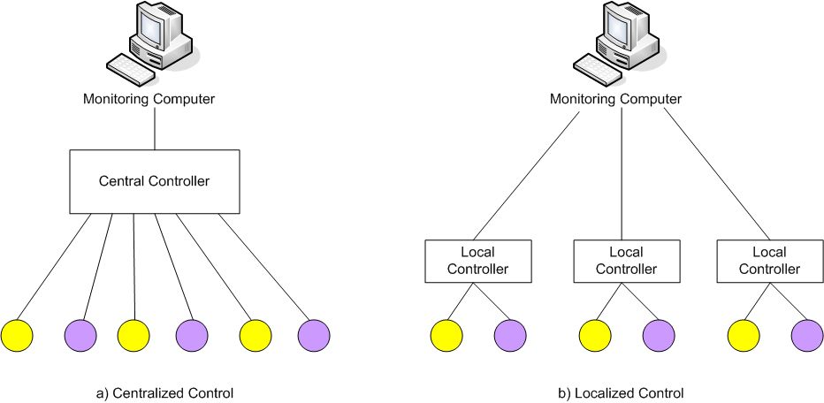
Figure 1.5 Comparing centralized control and localized control.
Centralized control is actually implemented in most industries. This has the advantage that the controller is safe from any process hazards. A certain communication protocol is needed to connect all of the sensors and actuators – each assigned with an address - to the central controller.
Localized control is what we have chosen. This has the advantage that control is not delayed or halted by any communication hazards that may occur between the sensors, actuators and the controller. Also, a controller may control more than one process. Moreover, there is more flexibility in adding new sensors, actuators, since they do not need to have certain interfaces or addresses as in the previous case. A certain communication protocol is needed to connect different controllers – each assigned with an address - to different monitoring stations.
After comparing the advantages and disadvantages of both types, we have chosen to implement localized control; i.e. we form a network of local controllers, each with its own address, to control nearby actuators and have a monitoring computer to receive the sampled values as well as giving control commands to the local controller.

